|  |  |
| --- | --- |
|  | **MATHEMATICS:SPECIALIST 1 & 2**  **SEMESTER 1 2019**  **TEST 1**  **Calculator Free** |

Reading Time: 2 minutes

Time Allowed: 30 minutes Total Marks: 29

Question 1 (3 marks)

Write the mathematical notation for the statement:

*For all rational numbers x, there exist integers y and w such that 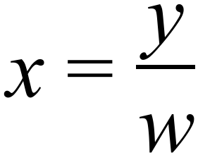 where w is non-zero.*

Question 2 (11 marks)

Three vectors are given by $a=3i-5j$, $b=-2i+7j$ and $c=6i+j$.

(a) Determine

(i) $a+b+c$. (1 mark)

(ii) $|c|$. (1 mark)

(iii) $2a+3b$. (2 marks)

(b) Determine the unit vector $\hat{d}$ that is parallel and in the same direction as $b-a$. (3 marks)

(c) Express $c$ in terms of $a$ and $b$. (4 marks)

Question 3 (8 marks)

(a) Write the inverse of the following true statement and comment on the truth of the inverse statement. (2 marks)

"If the discriminant of the quadratic formula is zero, then the quadratic has just one real root."

(b) Write the converse of the following true statement and comment on the truth of the converse statement. (2 marks)

"If $x>3$ then $x>2$."

(c) Determine the truth of the following statements, using an example or counter-example to support each answer.

(i) If $z∈R$ and $z^{3}$ is an even number then $z$ is an even number. (2 marks)

(ii) If $x,y∈Z$ and $x>y$ then $x^{2}>y^{2}$. (2 marks)

Question 4 (7 marks)

(a) A body moves from $P(2, -3)$ to $Q(-2, 1)$.

(i) Determine the displacement vector $\vec{PQ}$ in component form. (1 mark)

(ii) Determine the magnitude of the vector $\vec{PQ}$. (1 mark)

(b) A force of $6i-6\sqrt{3}j$ N acts on a body. Determine the magnitude of the force and the angle its direction makes with the positive $x$-axis. (2 marks)

(c) A body moves with a velocity of 20 ms-1 at an angle of 135° with the positive $x$-axis. Express the velocity of the body in the form $ai+bj$, where $a$ and $b$ are constants.

(3 marks)

|  |  |
| --- | --- |
|  | **MATHEMATICS:SPECIALIST 1 & 2**  **SEMESTER 1 2019**  **TEST 2**  **Calculator Assumed** |

Reading Time: 2 minutes

Time Allowed: 26 minutes Total Marks: 25

Question 5 (9 marks)

Points O, P, Q and R have position vectors , ,  and .

(a) Determine the value of y if . (2 marks)

(b) Determine the value of x if $\vec{OQ}$ is parallel to $\vec{QR}$. (3 marks)

(c) Determine the values of x and y if R lies on the line between P and Q such that . (4 marks)

**Question 6 (10 marks)**

Two tug boats are acting on a oil rig in a harbour where there is a strong tidal flow. The tug boat force vectors **F1**= 4000N and **F2** =5000Nare shown in the diagram.

(a) given the tidal flow exerts a force **F3**= 3000N on a bearing 170o T:(1 mark)

draw the vector for ***F3***on the diagram

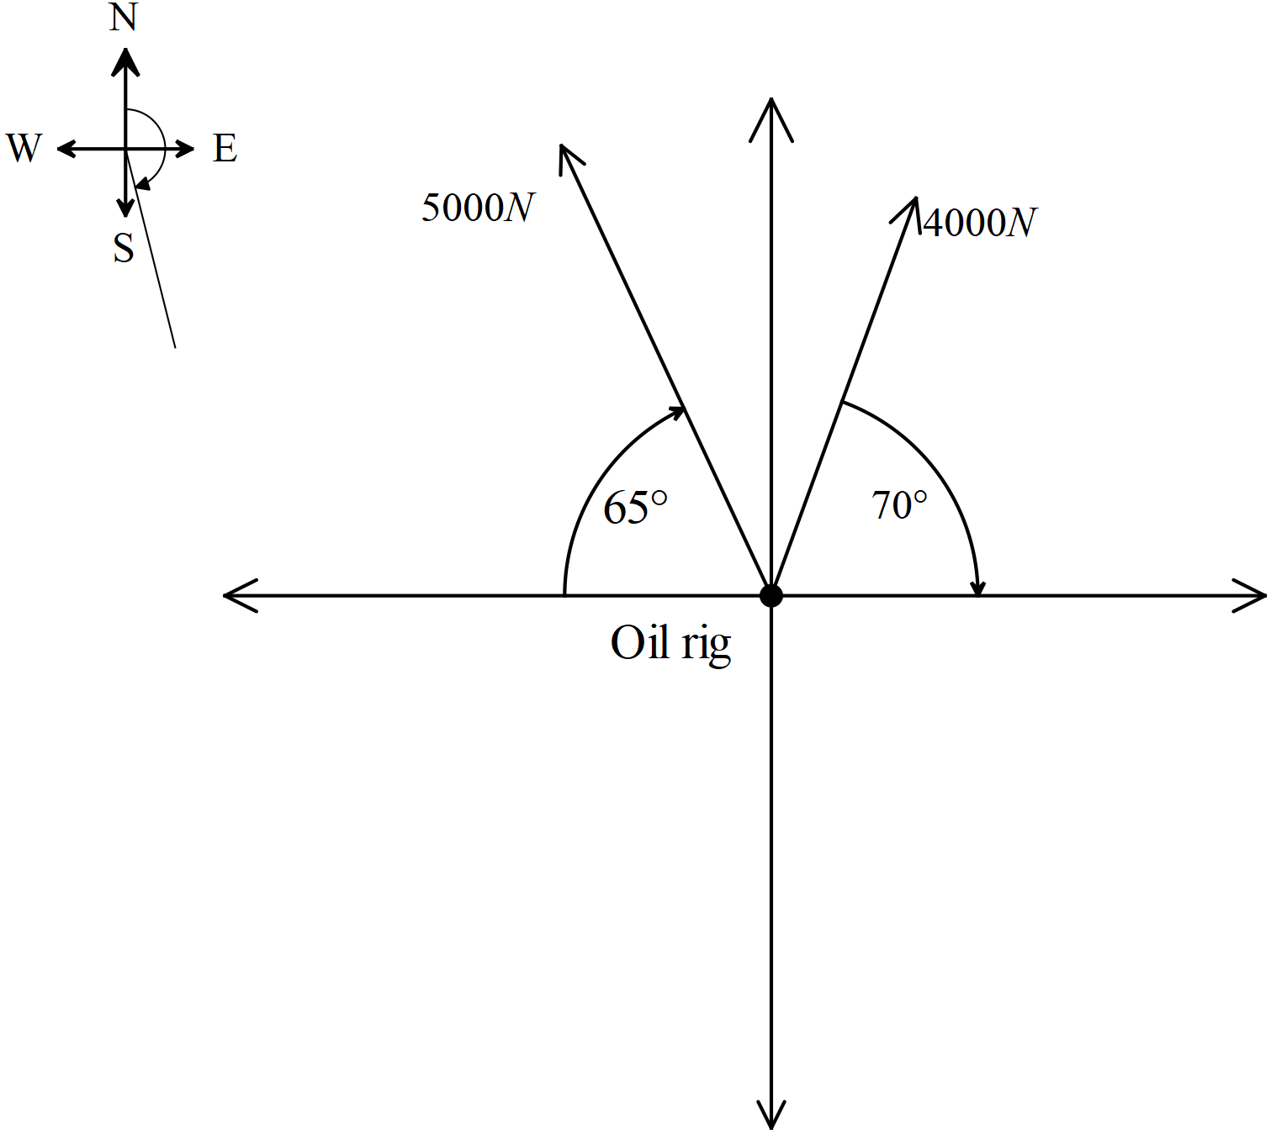

1. by calculating **F1 , F2**and **F3**in **i** and **j** component form calculate the resultant force in **i** and **j** form. (5marks)
2. give the magnitude and direction of the resultant force from above. (4 marks)

Question 7 (6 marks)

An aircraft is to be flown directly from A to B, where $\vec{AB}=$. A steady wind with velocity  is blowing. Determine the velocity the aircraft should steer in the form , given that the aircraft has a cruising speed of 420 km/h.